https://www.vultr.com/docs/install-sonarqube-on-ubuntu-20-04-lts

| ***Use AWS Ubuntu 20.04 t2.large*** |
| --- |
|  |

## **Install OpenJDK 11**

sudo apt-get install openjdk-11-jdk -y

## **Install Maven**

apt install maven -y

## **Install and Configure PostgreSQL**

sudo sh -c 'echo "deb http://apt.postgresql.org/pub/repos/apt/ `lsb_release -cs`-pgdg main" >> /etc/apt/sources.list.d/pgdg.list'

wget -q https://www.postgresql.org/media/keys/ACCC4CF8.asc -O - | sudo apt-key add -

sudo apt install postgresql postgresql-contrib -y

sudo systemctl start postgresql

sudo passwd postgres

su - postgres

createuser sonar

psql

ALTER USER sonar WITH ENCRYPTED password 'my_strong_password';

CREATE DATABASE sonarqube OWNER sonar;

GRANT ALL PRIVILEGES ON DATABASE sonarqube to sonar;

\q

exit

## **Download and Install SonarQube**

~~sudo apt-get install zip -y~~

~~sudo wget~~ [~~https://binaries.sonarsource.com/Distribution/sonarqube/sonarqube-9.0.1.46107.zip~~](https://binaries.sonarsource.com/Distribution/sonarqube/sonarqube-9.0.1.46107.zip)

~~sudo unzip sonarqube-9.0.1.46107.zip~~

~~sudo mv sonarqube-9.0.1.46107 /opt/sonarqube~~

sudo apt-get install zip -y

sudo wget https://binaries.sonarsource.com/Distribution/sonarqube/sonarqube-9.7.1.62043.zip

sudo unzip sonarqube-9.7.1.62043.zip

sudo mv sonarqube-9.7.1.62043 /opt/sonarqube

## **Add SonarQube Group and User**

sudo groupadd sonar

sudo useradd -d /opt/sonarqube -g sonar sonar

sudo chown sonar:sonar /opt/sonarqube -R

## **Configure SonarQube**

sudo nano /opt/sonarqube/conf/sonar.properties

Uncomment the lines, and add the database user and password you created in Step 2.

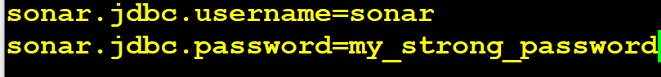

Add sonar.jdbc.url=jdbc:postgresql://localhost:5432/sonarqube below above two lines



Save and exit the file.

~~sudo nano /opt/sonarqube/bin/linux-x86-64/sonar.sh~~



## **Setup Systemd service**

sudo nano /etc/systemd/system/sonar.service

Save below text in the file and exit.

[Unit]

Description=SonarQube service

After=syslog.target network.target

[Service]

Type=forking

ExecStart=/opt/sonarqube/bin/linux-x86-64/sonar.sh start

ExecStop=/opt/sonarqube/bin/linux-x86-64/sonar.sh stop

User=sonar

Group=sonar

Restart=always

LimitNOFILE=65536

LimitNPROC=4096

[Install]

WantedBy=multi-user.target

sudo systemctl enable sonar

sudo systemctl start sonar

sudo systemctl status sonar

## 

## 

## 

## **Modify Kernel System Limits**

sudo nano /etc/sysctl.conf

vm.max_map_count=262144

fs.file-max=65536

ulimit -n 65536

ulimit -u 4096

Save and exit the file. Reboot the server.

Wait for 5 min and access the server on port 9000 as below

<http://ec2-3-228-22-190.compute-1.amazonaws.com:9000>

Default credentials admin/admin

Login and change the password.

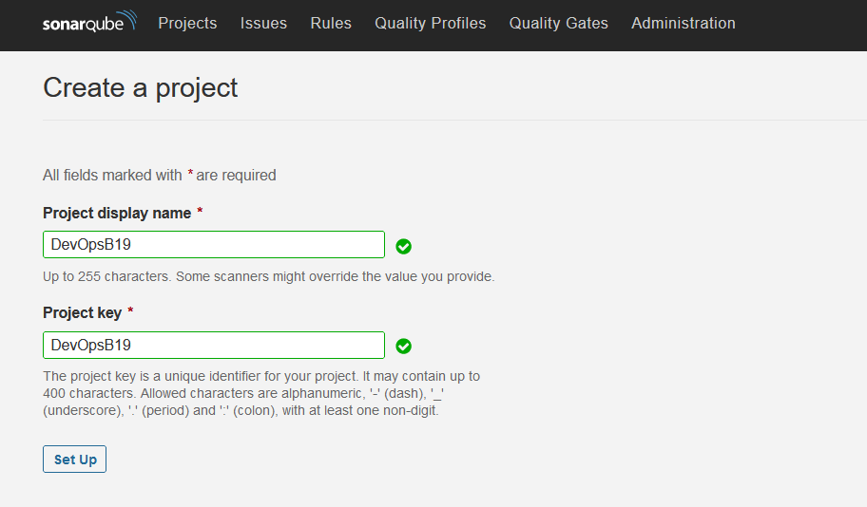

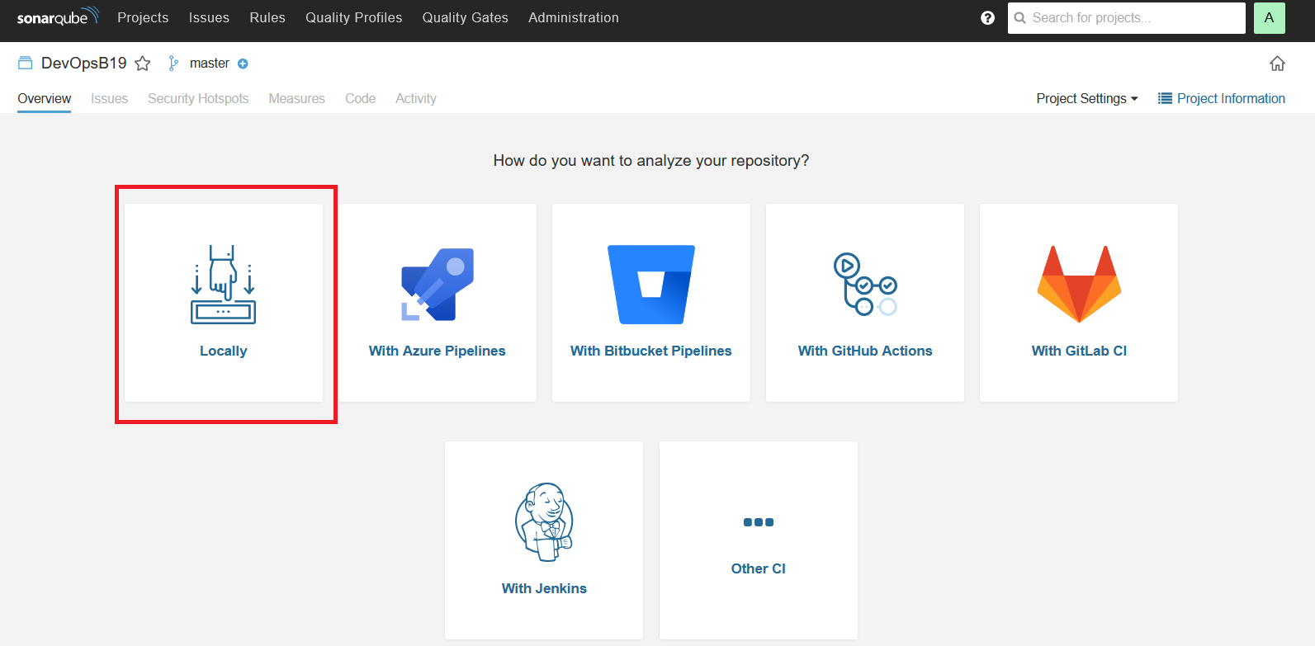

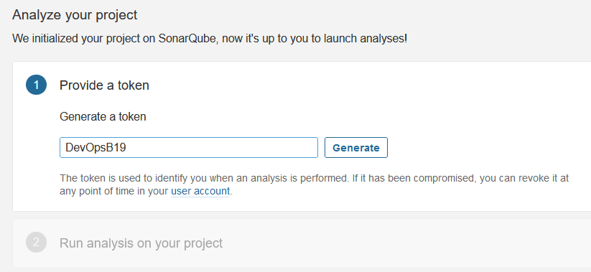

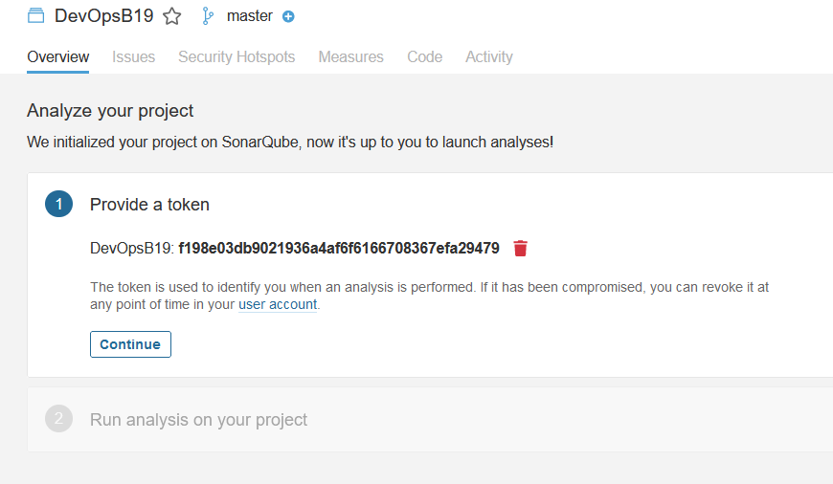

Sonarqube Jenkins integration:

<https://www.linkedin.com/pulse/enforce-quality-gates-using-sonarqube-jenkins-tarun-prakash/>

